**Methods**

**Environmental variables**

We used the WorldClim database (www.worldclim.org) which includes 19 bioclimatic variables, monthly precipitation, minimum, maximum and average monthly temperature, wind, vapor and solar radiation. Those variables that are identified as important in the model are shown in table 1.

**Generalized dissimilarity model**

The generalized dissimilarity model here after GDM is a matrix regression technique (Ferrier et al., 2007) to analyze and predict primarily beta diversity patterns. However, it was shown that GDM could be used to explore relationship between morphological traits variation and environmental variation (Thomassen et al., 2010; Baldassarre et al., 2013).

In GDM we use matrix correlation among biotic and environmental dissimilarity plus geographic distance between sample sites to predict biotic dissimilarity across landscape. One of the advantages of GDM is that it can fit nonlinear relationship of variables by the help of I-spline function. GDM consists of two steps; in the first step using all pairwise combinations of sampling sites, it fits dissimilarities in predictor variables (environmental variables) to dissimilarities in response variables (phenotypic variables). In this step all environmental predictors with sum of I-spline coefficients of zero were removed then the remaining environmental data were permuted and introduced in the random order to the model. GDM were fitted with these permuted data, and the result of deviance explained by this model compared with deviance explained by GDM fitted to unpermuted data. Predictors importance is calculated based on the difference in deviance explained between permuted model and unpermuted model. In this step backward elimination could be used so that less important predictors were dropped from the model (Ferrier et al., 2007). In the final step, using the result of above procedures spatial prediction of response variables pattern across the entire range of study areas were made.

For each response variable we ran four different models. Ful model that includes environmental and geographic distance as predictor variables. To examine possible correlation between geographic distance and environmental dissimilarity, we ran two additional models each selecting only one of them (geographic distance and environmental dissimilarity) as predator variables. We also ran a random model to compare with fitted models to make sure null hypothesis were not rejected randomly. To run random model, we produced random values of environmental variables for each location and as we have few locations, we produced 100000 random models. Then we used mean deviance explained by these random models and compared them with full, environment and geographic distance models. If the difference between deviance explained by random model were lower than any other three models, we consider the relationship of response variables with predictor variables not random (Thomassen et al., 2010; Baldassarre et al., 2013).

**Results**

We ran full model (environmental variables and geographic distance as predictor variables), environmental model (only environmental variables were used as predictor variables) and geographic distance model (only geographic distance were used as predictor variables) for all phenotypic traits. As we mentioned in the method for verifying the performance of the models, we compare the deviance explained by each model to the deviance explained by random model (t-test comparison of mean deviance explained by environmental models and random models: t = 9.33, df = 8.97, p < 0.001, CI = 54.36). Environmental models explained most of the proportion of variation in all phenotypic traits compare to full and geographic distance models (Table 2). The geographic distance model did not explain the variation on any phenotypic traits (Table 3). For all phenotypic variables, the environmental model (range= 43.69-78.52 mean = 60.53 SD = 12.39) explained most of the variation than associated random model (range = 11.18-24.08, mean = 16.78, SD = 4.70). Eight phenotypic variables showed relationship with some of the predictor variables. There was a different combination of predictor variables for each phenotypic trait (Table 3). Two predictor variables that influenced fecundity (Fec), solar radiation in January and wind speed in July were identified; however, solar radiation in January has response cure dramatically higher than wind speed in July (Figure 1). The environmental model explained most of the variation in male dry weight (64.05%) derived from bio 02 (diurnal temperature range) and water vapor pressure in July (Table 3). Life span in male and female and thorax length in female had more than two predictor variables that explained their variation (Table 3). Solar radiation in May was the most important predictor of variation of life span in male and female (Figure 1). The most of variation in thorax length was explained by solar radiation in June and followed by precipitation in May (Figure 1).

Table 1: predictor variables identified as important in GDMs.

|  |  |  |
| --- | --- | --- |
| Number | Predictor variable name | Predictor variable abbreviation |
| 1 | Mean Temperature of Warmest Quarter | Bio 10 |
| 2 | diurnal temperature range | Bio 02 |
| 3 | Mean Temperature of Wettest Quarter | Bio 08 |
| 4 | precipitation (mm) in May | Prec 05 |
| 5 | precipitation (mm) in October | Prec 10 |
| 6 | solar radiation (kJ m-2 day-1) in January | Srad 01 |
| 7 | solar radiation (kJ m-2 day-1) in May | Srad 05 |
| 8 | solar radiation (kJ m-2 day-1) in June | Srad 06 |
| 9 | average temperature (°C) in June | Tavg 06 |
| 10 | water vapor pressure (kPa) in June | Vapr 06 |
| 11 | water vapor pressure (kPa) in July | Vapr 07 |
| 12 | water vapor pressure (kPa) in August | Vapr 08 |
| 13 | wind speed (m s-1) in July | Wind 07 |
| 14 | wind speed (m s-1) in August | Wind 08 |
| 15 | wind speed (m s-1) in December | Wind 12 |

Table 2: proportion of variation in phenotypic variables that explained by each model

|  |  |  |  |
| --- | --- | --- | --- |
| Phenotypic variables | Full model | Environmental model | Geographic distance model |
| DW_M | 0.012 | 0.987 | 0.001 |
| Fec | 0.169 | 0.831 | 0.000 |
| LS_F | 0.035 | 0.965 | 0.000 |
| LS_M | 0.010 | 0.990 | 0.000 |
| TL_F | 0.066 | 0.934 | 0.000 |
| WA_L_M | 0.054 | 0.946 | 0.000 |
| WA_R_F | 0.114 | 0.886 | 0.000 |
| WA_R_M | 0.078 | 0.922 | 0.000 |

Table 3: result of generalized dissimilarity model for phenotypic variables, the most important predictor variables were shown in bold.

|  |  |  |  |
| --- | --- | --- | --- |
| Phenotypic variables | Environmental model | | Random model |
| Deviance explained | Important predictors | Deviance explained |
| DW_M | 64.05 | **Bio 02**, Vapr 07 | 12.15 |
| Fec | 78.52 | **Srad 01**, Wind 07 | 20.08 |
| LS_F | 63.87 | Bio 10, **Srad 05**, Tavg 06, Vapr 06, Wind 08 | 19.82 |
| LS_M | 63.91 | Prec 10, **Srad 05**, Srad 06, Wind 12 | 15.46 |
| TL_F | 65.35 | Prec 05, Srad 01, **Srad 06**, Wind 12 | 19.22 |
| WA_L_M | 40.62 | Vap 06, **Wind 08** | 11.18 |
| WA_R_F | 64.23 | Bio 08, Vapr 08, **Wind 08** | 24.08 |
| WA_R_M | 43.69 | Vapr 06, **Wind 08** | 12.22 |

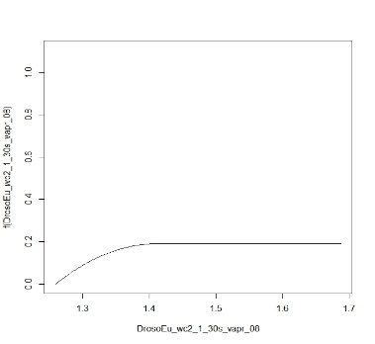

**WA_R_F**

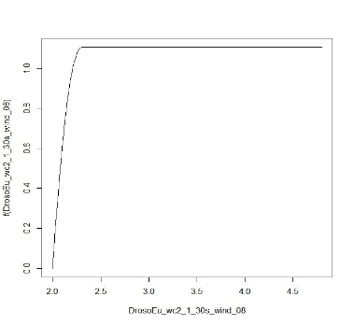

**WA_R_F**

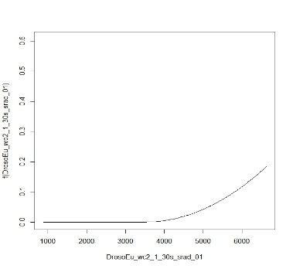

**TL_F**

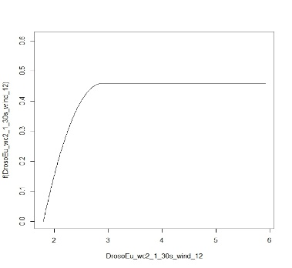

**TL_F**

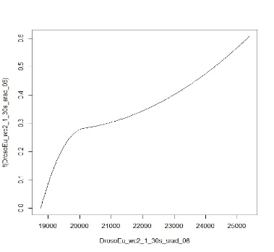

**TL_F**

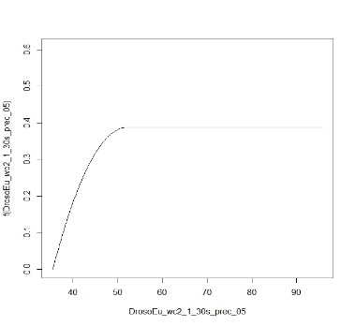

**TL_F**

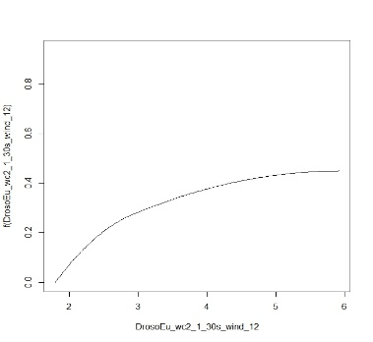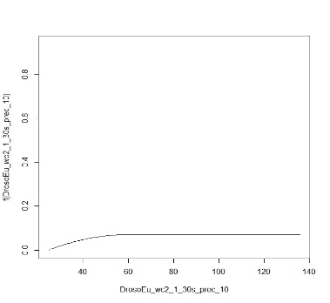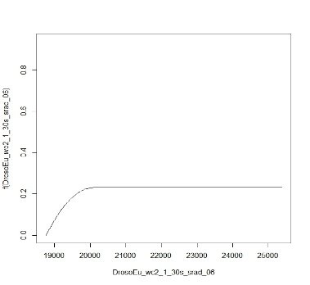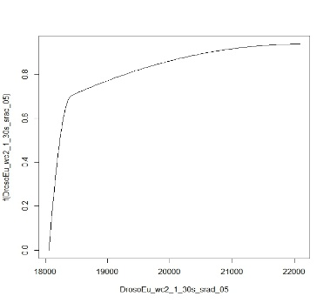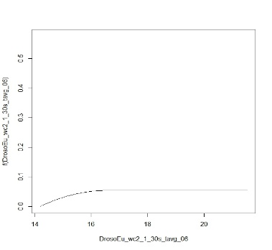

**LS_F**

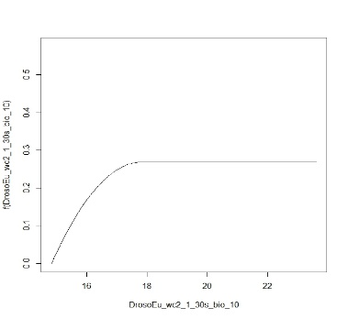

**LS_F**

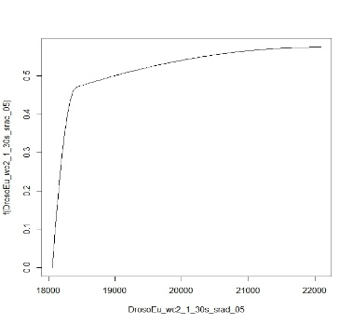

**LS_F**

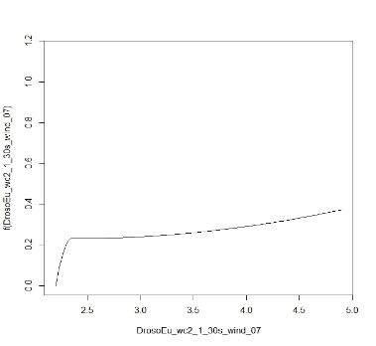

**Fec**

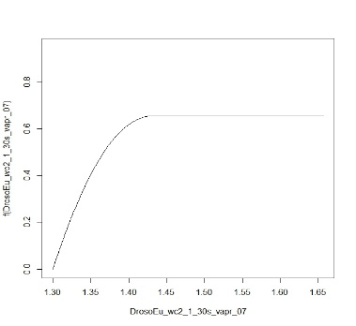

**DW_M**

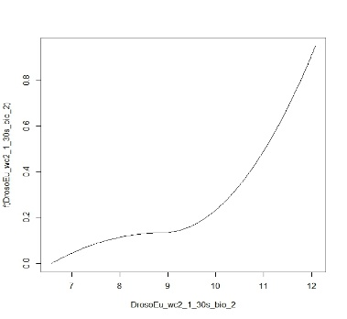

**DW_M**

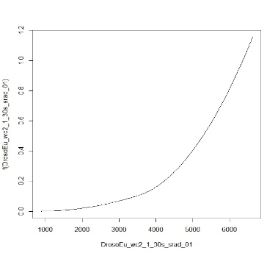

**Fec**

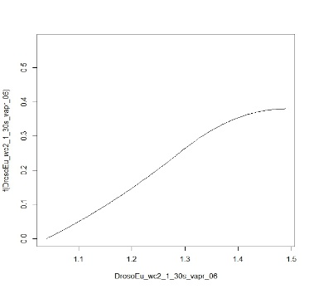

**LS_F**

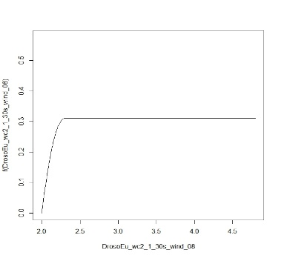

**LS_F**

**LS_M**

**LS_M**

**LS_M**

**LS_M**

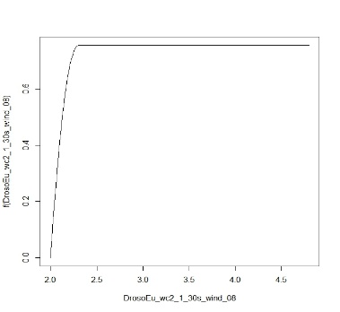

**WA_L_M**

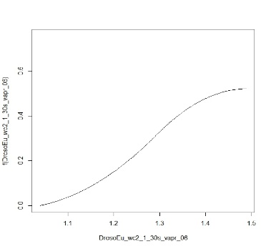

**WA_L_M**

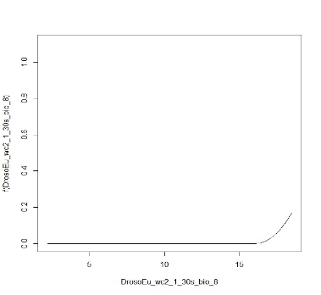

**WA_R_F**

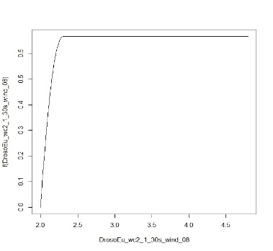

**WA_R_M**

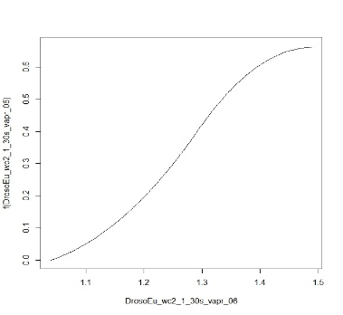

**WA_R_M**

Figure 1: I-spline produced for important predictors (environmental variables) from the GDMs. The maximum of each curve indicated amount of variation in phenotypic variables with respect to the predictor variable.

References

Baldassarre, D. T., Thomassen, H. A., Karubian, J., & Webster, M. S. (2013). The role of ecological variation in driving divergence of sexual and non-sexual traits in the red-backed fairy-wren (Malurus melanocephalus). *BMC Evolutionary Biology, 13*(1), 75. doi:10.1186/1471-2148-13-75

Ferrier, S., Manion, G., Elith, J., & Richardson, K. (2007). Using generalized dissimilarity modelling to analyse and predict patterns of beta diversity in regional biodiversity assessment. *Diversity and Distributions, 13*(3), 252-264. doi:<https://doi.org/10.1111/j.1472-4642.2007.00341.x>

Thomassen, H. A., Buermann, W., Milá, B., . . . Smith, T. B. (2010). Modeling environmentally associated morphological and genetic variation in a rainforest bird, and its application to conservation prioritization. *Evolutionary Applications, 3*(1), 1-16. doi:<https://doi.org/10.1111/j.1752-4571.2009.00093.x>